Exp. 5. Band Structure Simulation for Graphene and CNTs using NanoHub

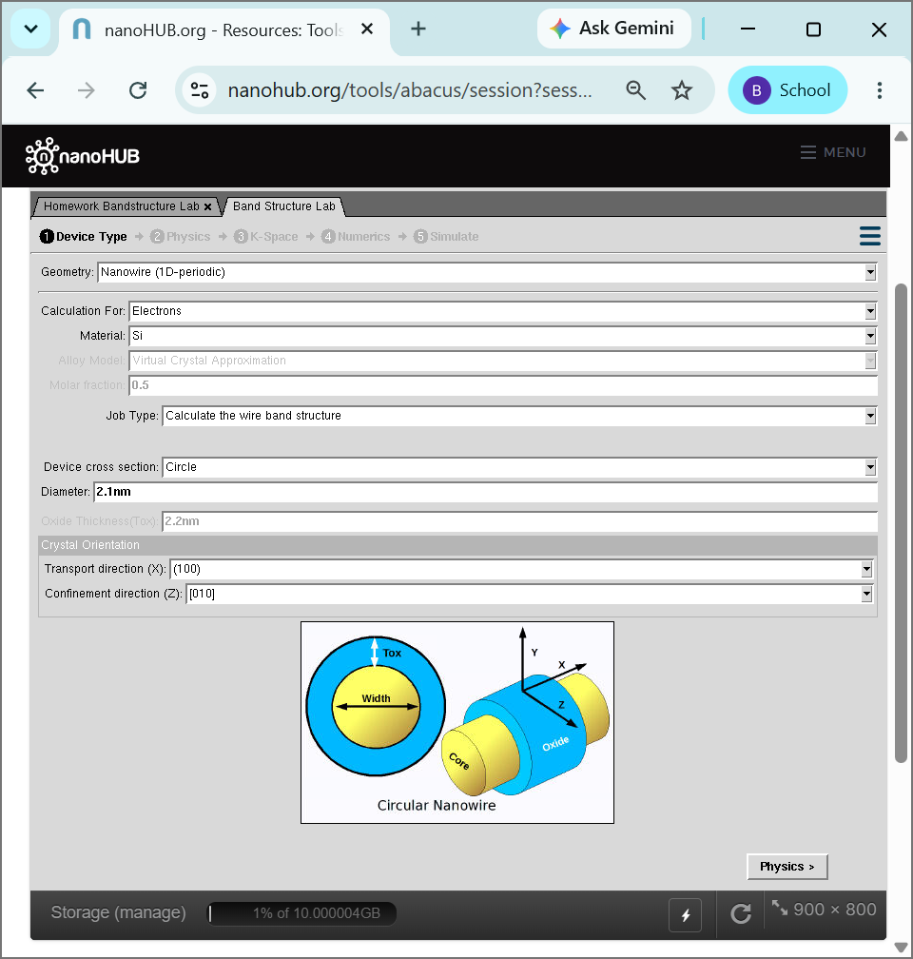
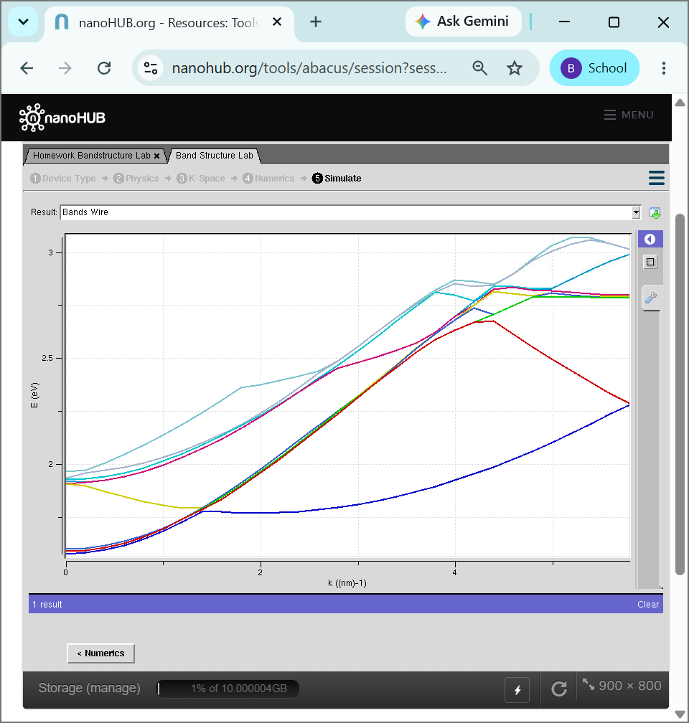
Case Study 1: Simulate the band-structure of InAs circular nanowire
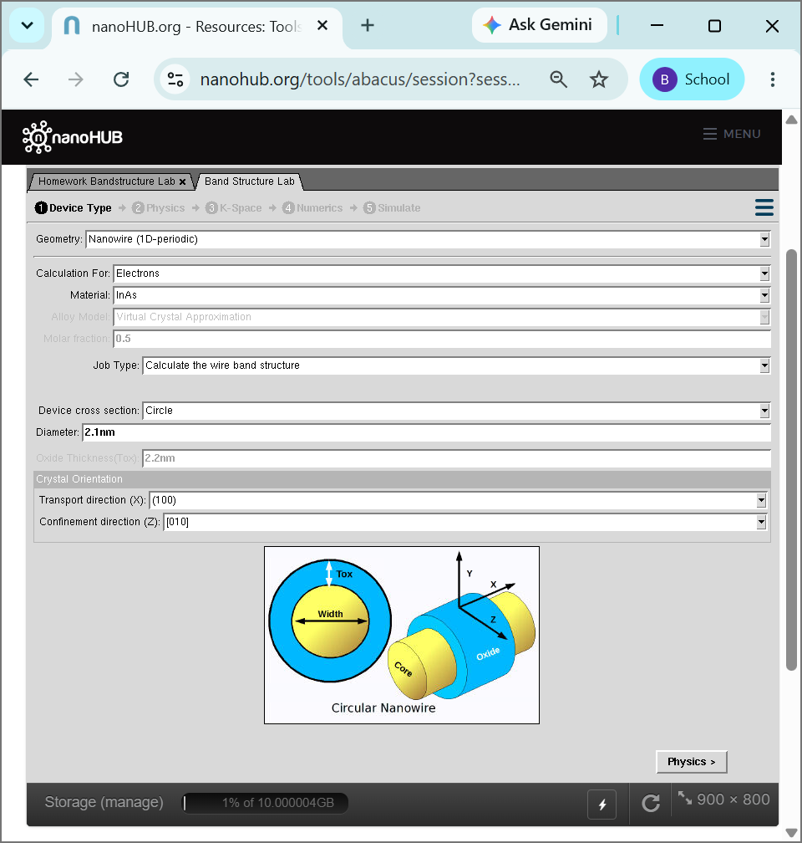
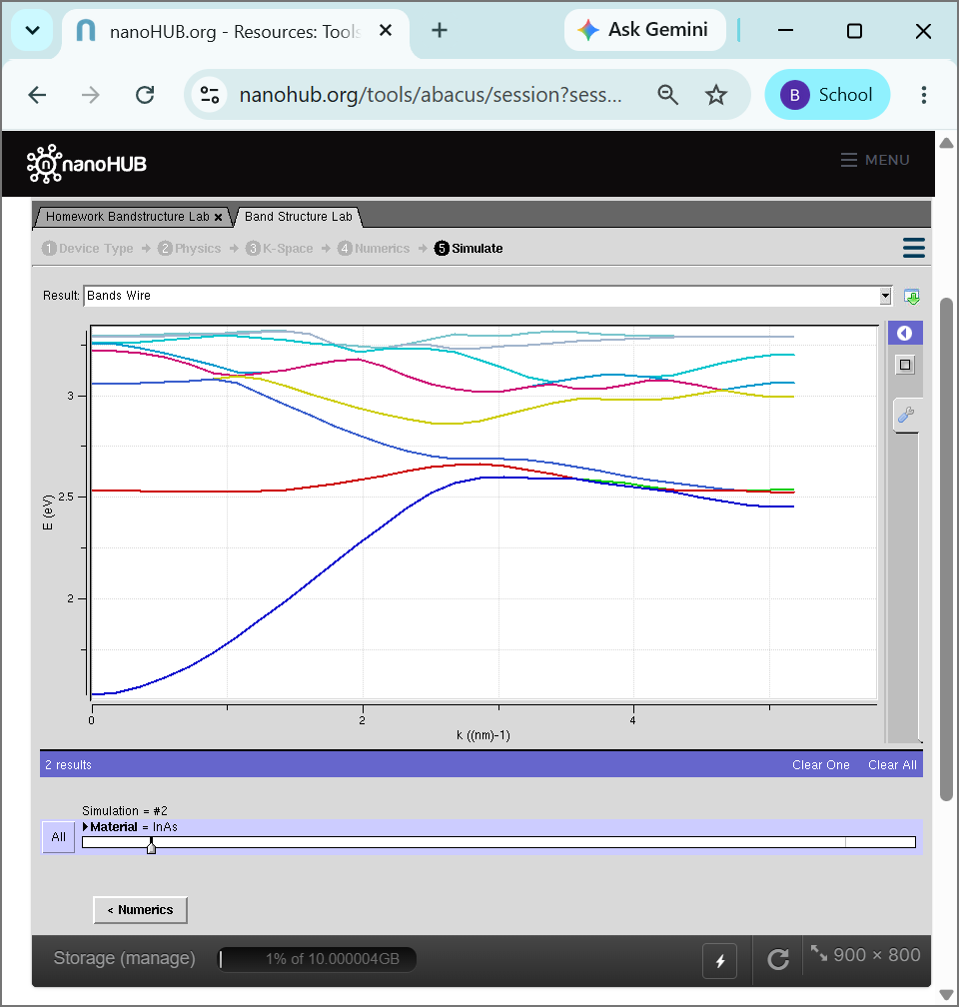
Case Study 2: Simulate the band-structure of AlGaAs circular nanowire
